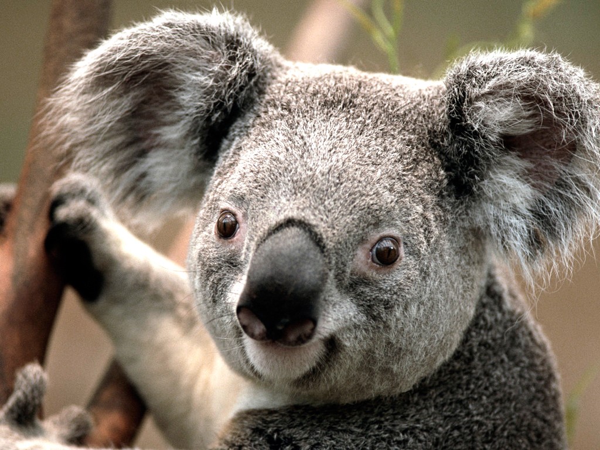

RUCHITH A

**CAREER OBJECTIVES**

**ACADAMIC BACKGROUND**

2018-2020 :MBA

2015-2018 :Bcom

2013-2015 :PUC

2013 :10

**INTERNSHIP**

**INTEREST**

**ABOUT ME**

Date Of Birth: 23/07/1996

Age :23

Gender :male

Birth Place :chintamani

**CONTACT :**

Address :chintamani

Phone :8553871460

Email :96ruchith.a@gmail.com

**SKILLS :**

**EXPERTISE**